1. Go to [www.sec.gov](http://www.sec.gov)
2. There is a link for ‘More search options’ at the top of the page

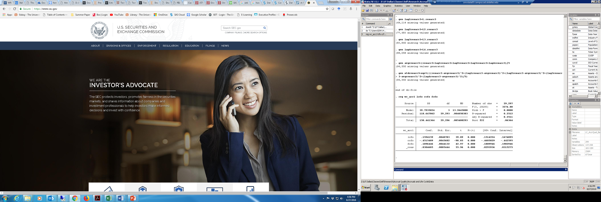

1. In that, there is a field for CIK number – I will give you a list of CIK numbers with the relevant details to test the code

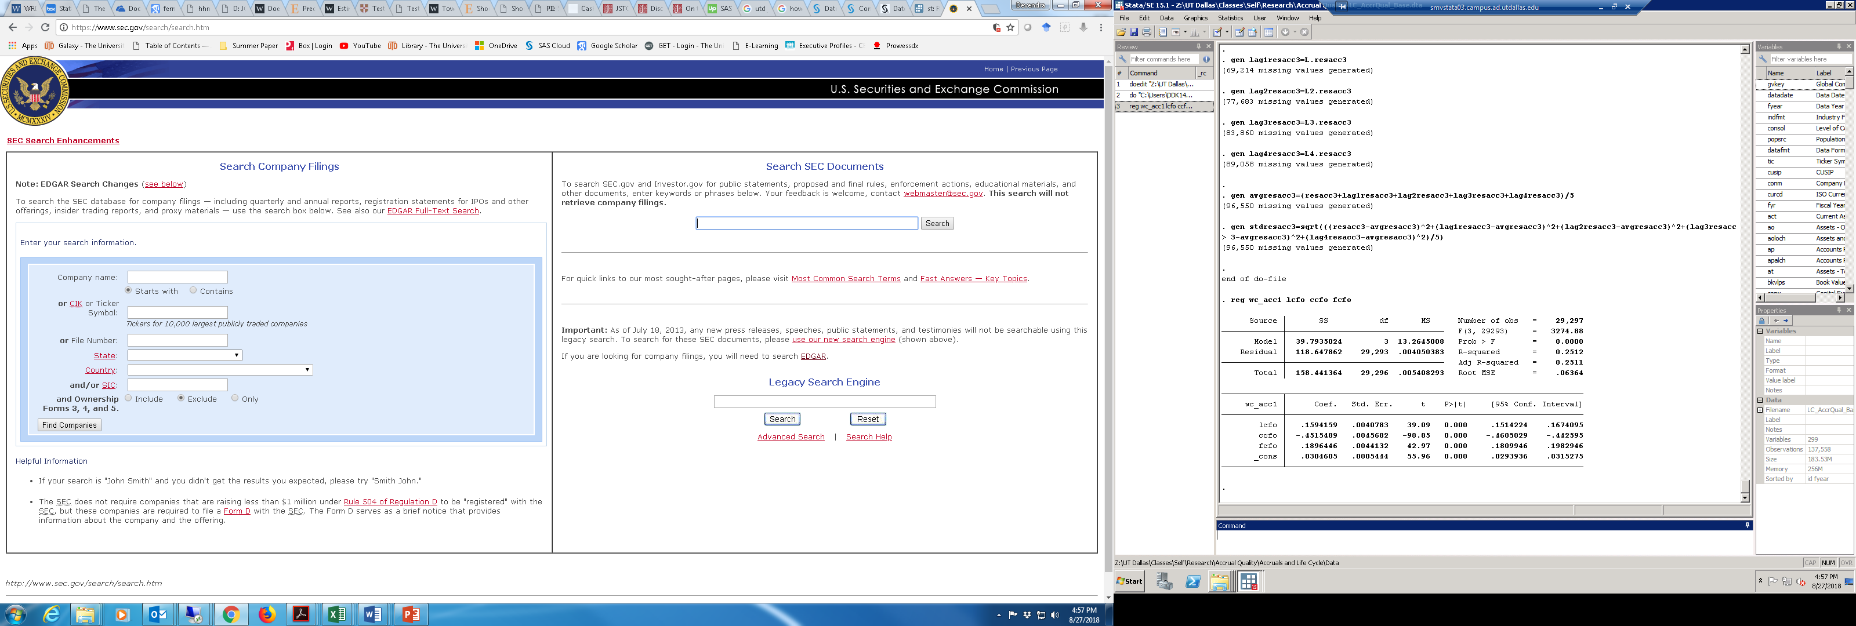

1. The excel file I will use will have a list of CIK numbers and the relevant filing dates. Please note that the content from the website needs to be downloaded for each CIK-filing date combination
2. To select, click on Find Companies



1. After you select the CIK number, it will go to the next page.

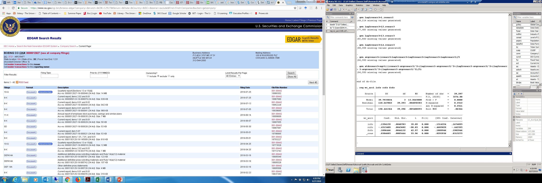

1. On this page, there is a box for Filing Type – please enter 10-K in that box, and click on search



1. The revised search results will look like this

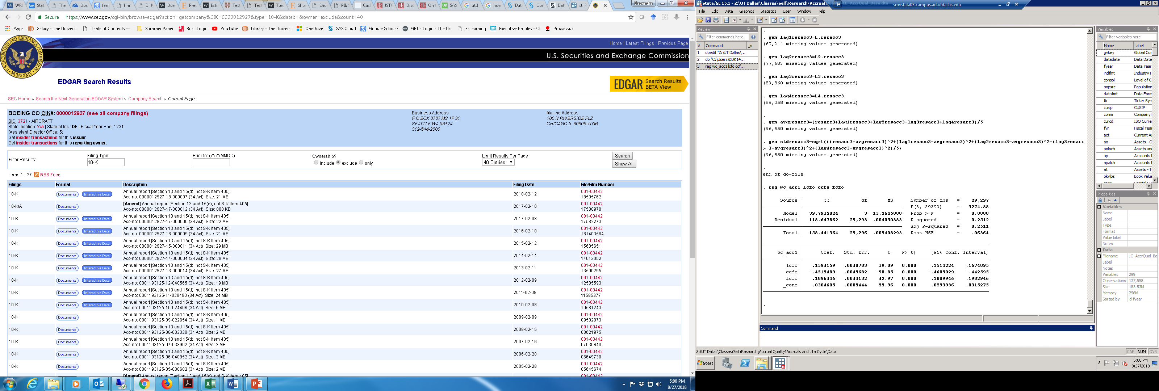

1. Now, from the excel file, for each CIK number, take the filing date field, and match it with the filing date field on that list



1. Please note that the filing date field in the excel file is the full date, but the one on the SEC website has ‘-‘ to separate the year, month and day
2. For each filing date, click on the documents button



1. When you click on this, it will take you to the next page

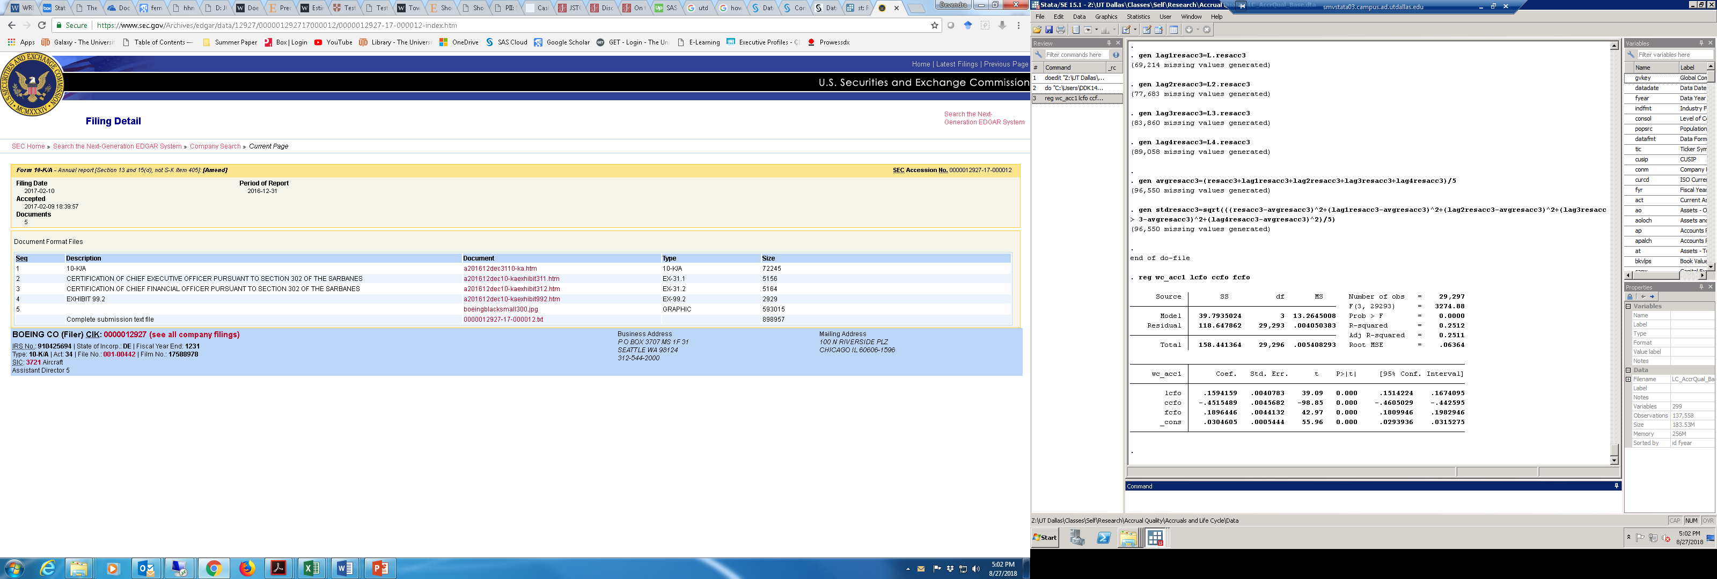

1. Click on the link which has 10-K or 10-K/A written against it



1. This will open the 10-K submission text. On this page, there are the following things to be done
   1. Search for keywords. To test, you can use the following: promotion, resign, resignation, retire, retirement, has retired, will retire.
   2. Once the program finds a result, it should code that CIK-filing date combination as 1, in another excel file. This is to identify that one of the keywords has been mentioned
   3. Count the number of times the keywords have been mentioned
   4. It should also download the paragraph or the entire text (in PDF??), or at least the link for that text
2. The same thing should be repeated for all CIK-filing date combinations